Table 1: Description of Virtual Reality Games

Name of Game | Description
Trash Bin Game | The player must shift their center of pressure (COP) left or right to move a trash bin to catch falling waste, which only falls vertically. The difficulty of the game can be increased by increasing the rate at which paper falls. The game can be played shifting COP while side-stepping or while walking by adjusting spatiotemporal gait parameters. A screen capture is shown below.  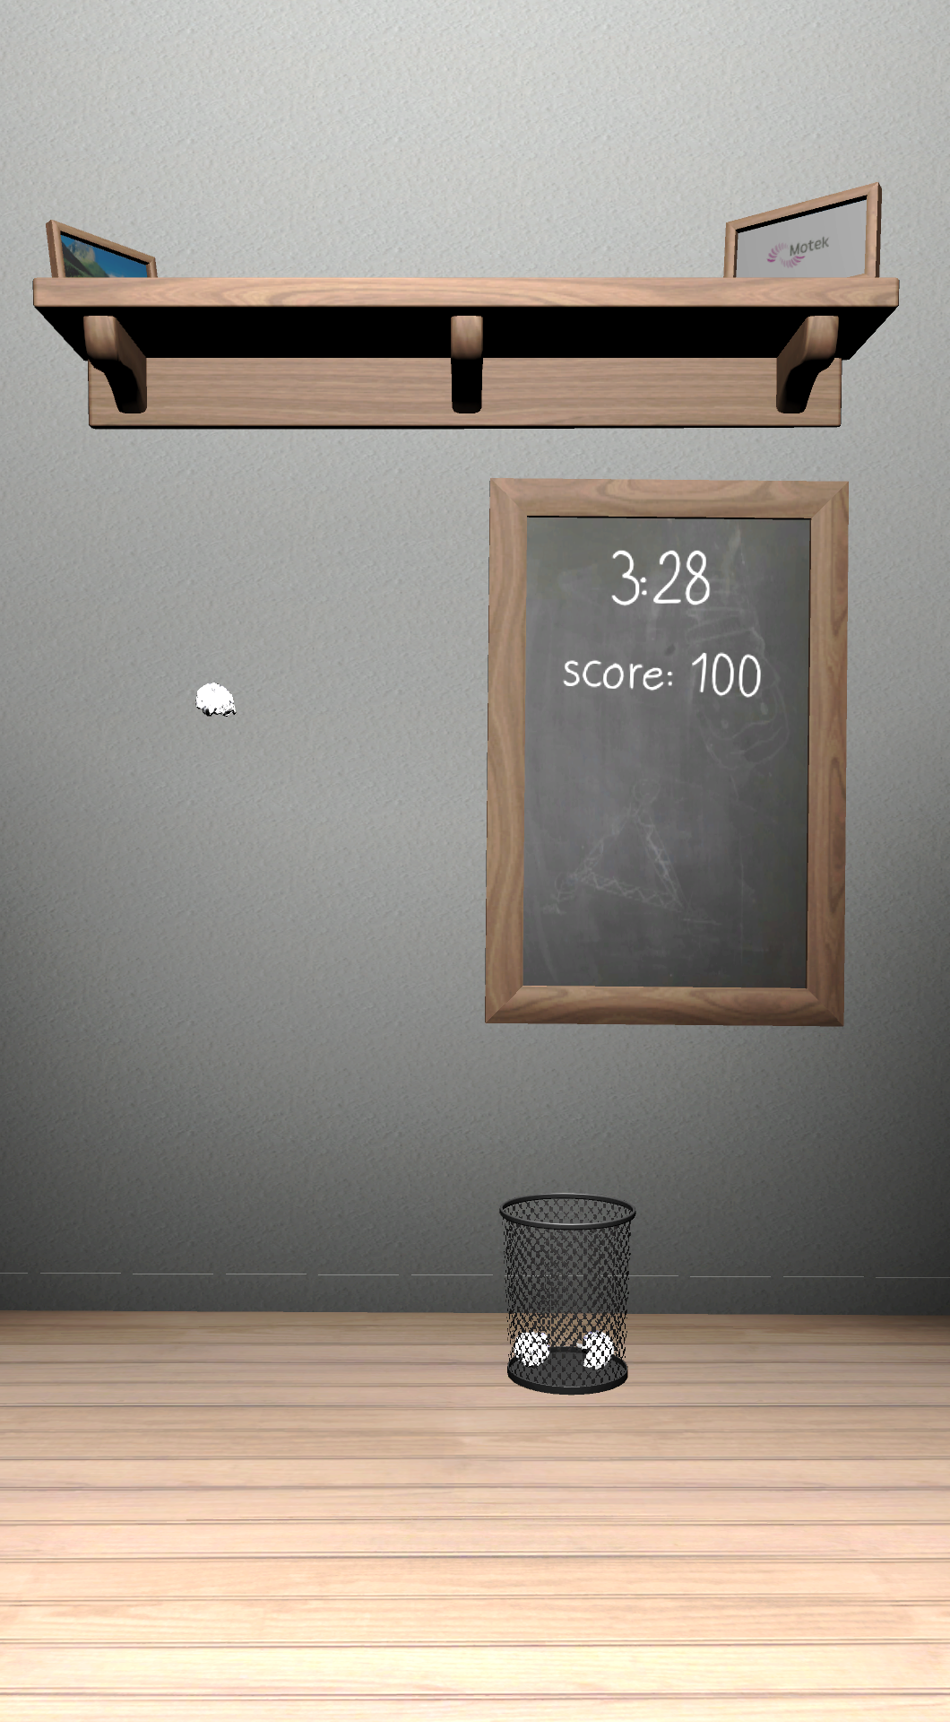
Traffic Jam | The goal of Traffic Jam is to allow cars, moving in two directions, to pass through an intersection, which is blocked when standing on both legs. The intersection clears by unloading one limb and shifting weight over the limb; if cars are in the right lane then weight must be shifted to the left limb (left yellow foot print will disappear) and vice versa to clear the intersection. Traffic Jam focuses on limb loading and unloading and is only played while keeping both flat on the ground. A screen capture is shown below.  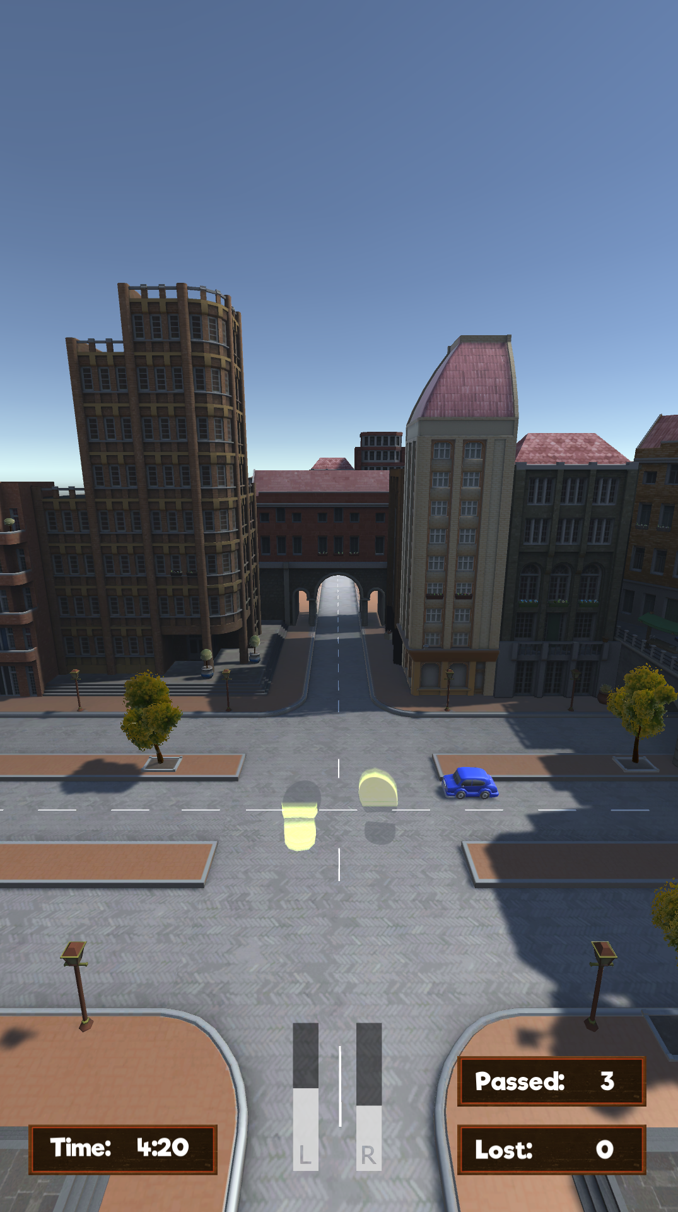
Playing Soccer | Playing Soccer is initially played while shifting weight side to side and standing in place. Like the Trash Bin Game It can also be played shifting weight by side-stepping or by altering stepping parameters (step length, step width and stance time) while walking. However the side-stepping and walking options are not shown until later in the intervention. In all modes of the game, balls are dropped from the sky and fall downwards on the screen and the goal is to continuously bounce the ball off of a paddle, which can be moved by side-to-side shifting of the center of pressure. The ball may bounce off the paddle, causing the ball to ricochet off of side nets. For every 10 bounces in a row an additional ball falls. Each gaming mode (standing, side-stepping or walking) has three levels of difficulty defined by the length of the paddle (decreasing the length of the paddle increases difficulty). A screen capture is shown below.  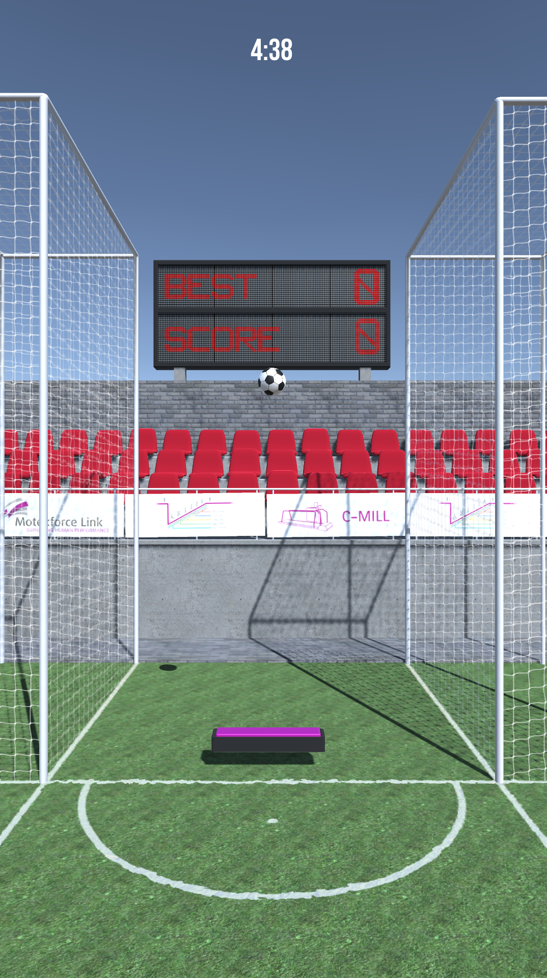
Playing Arkanoid | Playing Arkanoid game is first played while standing in place. It can also be played in side-stepping mode or walking mode, but these modes are not shown until later in the intervention. In Playing Arkanoid, a ball is dropped from the sky and falls downwards on the screen. The goal is to continuously bounce the ball off of a paddle so that the ball hits and breaks a series of bricks at the top of the screen; after hitting the bricks the balls again falls down to the paddle. The paddle can be moved by shifting the COP. The ball can bounce off of side walls. A screen capture is shown below.  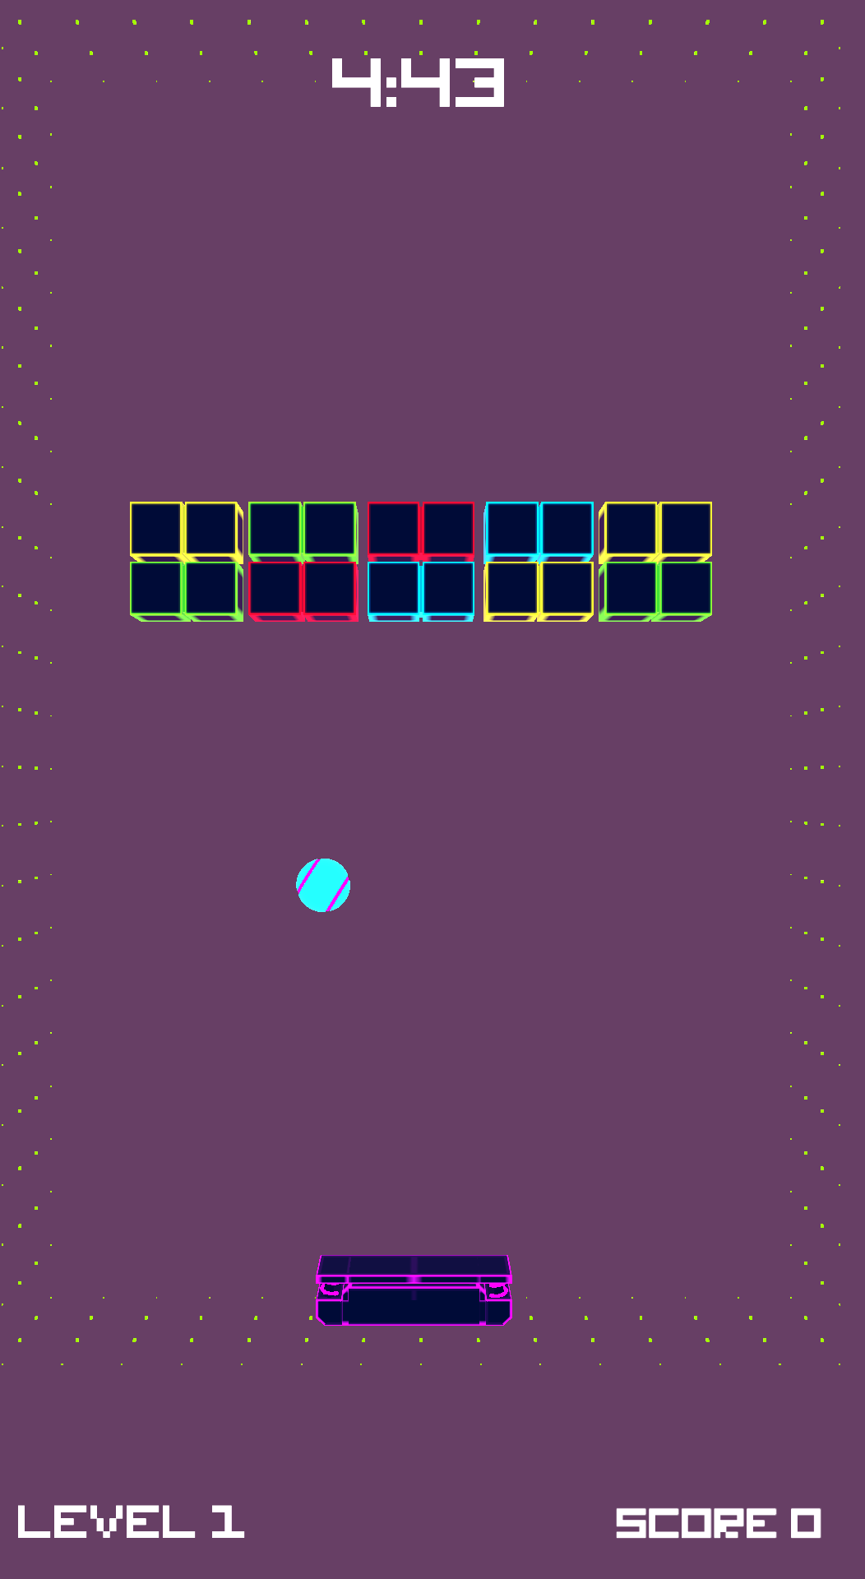
Forest Walk Game | Forest Walk is played only in walking mode. A forest scene is projected on the treadmill surface and animals and other objects appear and travel with the speed of the treadmill belt; the goal is to make on-line adjustments to the gait pattern in order to avoid stepping on the animals or other objects while intentionally stepping on projected stars and soccer balls; points are awarded for stepping on the proper objects and points are subtracted for stepping on all other objects. The game targets gait adaptability. An overhead view of the treadmill is shown below.  
Italian Alps Game | The Italian Alps Game is only played in walking mode. In Italian Alps, the player “pushes” a cart through a street and must collect ingredients to make a pizza (see bar across the bottom horizontal bar) to make a pizza while avoiding crashing into other objects such as flower boxes. The motion of the cart tracks the center of pressure (COP) and the flow of the scene is dictated by walking speed. A screen capture is shown below.  